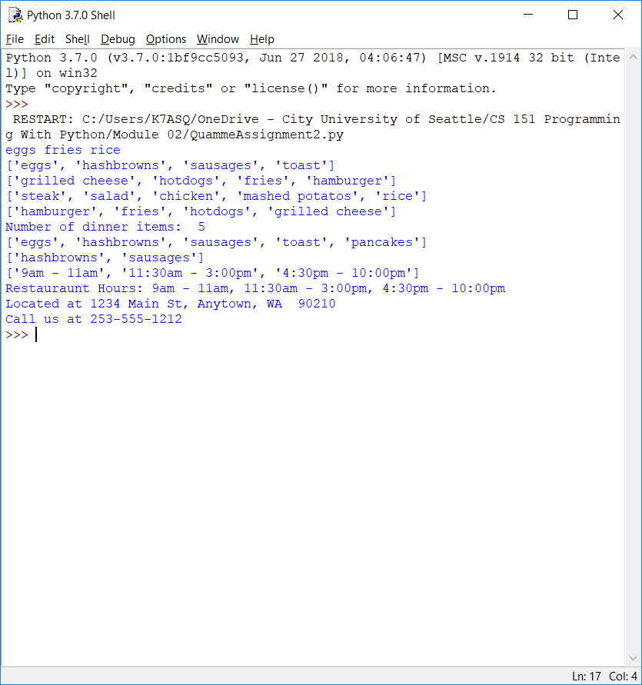

This week I was a little confused after reading the lesson, but after working through some of the examples and the assignment I feel more comfortable applying the lesson. Making the program for the assignment, I knew what methods were available for me to use and only needed to reference the text for help with syntax. By the end of the module I felt fairly comfortable. I am still a little unsure when to use a list vs a tuple, but I understand the difference between them. I have a feeling it will make more sense when getting into functions later in the course.